DEPARTMENTAL DEVELOPMENT PLAN EVALUATION “LOS QUE SOÑAMOS SOMOS MAS," YEAR 2018.-

The Monitoring Report to the Departmental Development Plan (DDP) 2018, aims to establish the level of progress and compliance of each of the strategic components that make up the DDP, in terms of compliance with the product goals of the Departmental Development Plan (Effectiveness) and the progress in the execution of financial resources established for the fulfillment of these goals (Efficiency).

Therefore, this report provides an evaluation corresponding to the year 2018, whose applied monitoring methodology includes the Strategic Programs and Projects. The follow-up is carried out after verifying the weighted fulfillment of the goals of all the products that are part of each of the main axis, calculating the effectiveness of the Plan and of each of its levels, facilitating the calculation of the Efficiency carried out for the fulfillment of goals of the Departmental Development Plan.

Taking into account the following table, it is possible to evaluate each Secretariat, according to their achievement.

PERCENTAGE | DESCRIPTION
0% - 59% | UNFAVORABLE
60% - 79% | FAVORABLE WITH OBSERVATION
80% - 100% | FAVORABLE

Below we will appreciate in detail the evaluation by Components:

1. STRATEGIC COMPONENT: A MORE TRANSPARENT ARCHIPELAGO
It includes the processes of institutional strengthening as well as the articulation with the community and other state institutions for a peaceful coexistence. It also seeks to establish a very direct relationship with the community through various mechanisms of accountability and online information on the daily tasks of the Administration, with the ability to listen and allow the active participation of citizens.

GENERAL OBJECTIVE
Establish efficient, effective and assertive communication channels in order to improve the response capacity of the Departmental entity towards citizens and their rights to be informed and to participate actively and permanently in the Departmental Government. It is expected at the end of the 4 years of government, to have a better Governmental scheme by having the most important asset of a government: the TRUST of the citizen for an advanced management with responsibility, seriousness, transparency and always facing the citizens of the Archipelago.

ANALYSIS
After analyzing the table below, it is observed that the STRATEGIC COMPONENT: A MORE TRANSPARENT ARCHIPELAGO, where the programs related to INTEGRAL REPAIR OF VICTIMS AND PROMOTION OF INITIATIVE OF HUMAN RIGHTS, PEACE AND / OR RECONCILIATION belonging to the Secretariat Government and Social Development have not carried out actions aimed at the goals that lead to the fulfillment of the programs; similarly occurs with the STRENGTHEN THE ACTIONS FOR AN INTEGRAL MANAGEMENT OF RISK OF DISASTERS, CARE IN FAMILY COMMISSIONER AND INTEGRAL CARE FOR VICTIMS programs; these generate an unfavorable result, finding another seven programs with unfavorable results with observation which generates an UNFAVORABLE RESULT WITH OBSERVATION to this component and to the achievement of the objective, despite the fact that it tends towards better governability.

RESULT: STRATEGIC COMPONENT: A MORE TRANSPARENT ARCHIPELAGO

M. IDEA | SECRETARIAT | COMPONENT | PROGRAM | EVAL.
A More  Transparent Archipelago | FINANCE | STRENGTHENING OF THE  DEPARTAMENTAL  ADMINISTRACION | STRENGTHENING AND MODERNIZATION OF PUBLIC FINANCES. | 75
 | GENERAL S. | GOVERNABILITY | INSTITUTIONAL MODERNIZATION | 99,8
 |  |  | PUBLIC MANAGEMENT AND TRANSPARENCY | 86,9
 | PRESS |  | PUBLIC COMMUNICATION AS A COLLECTIVE  HERITAGE | 100
 | GOVERNMENT | CITIZEN PARTIOPACION ,  DEMOCRATIC AND  COMMUNITY | MORE CITIZENS PARTICIPATING | 69.4
 |  |  | DEMOCRATIC PROCESSES FOR ALL | 75
 |  |  | COMMUNITY ORGANIZATIONS MORE STRENGTHENED | 76.8
 |  |  | CHARACTERIZATION AND IDENTIFICATION OF SOCIAL GROUPS | 100
 |  | SAFE AND PEACE TERRITORIES | MORE JUSTICE, SECURITY, AND CITIZEN COEXISTENCE  SPACE | 74.4
 |  |  | JUSTICE, SECURITY, AND LIVING | 75
 |  | GUARANTEE OF RESPECT TO A  HR&IHM | TERRITORY WITH MORE HUMAN RIGHTS | 83.2
 |  |  | MORE TOLERANCE & MORE CULTURE OF HUMAN RIGHTS | 66.6
 | S. DEVELOPMENT |  | MORE ATTENTION TO VICTIMS | 66.6
 |  |  | INTEGRAL ATTENTION TO VICTIMS | 49
 |  |  | INTEGRAL REPAIR TO VICTIMS | 0
 | GOVERNMENT AND  S. DEVELOPMENT |  | PROMOTION OF HUMAN RIGHTS INITIATIVE, PEACE  AND / OR RECONCILIAOON | 0
 | GOVERNMENT AND  FAMILY WELFARE A. |  | ATTENTION TO FAMILY WELFARE AGENCY | 16,6
 | Office of Risk  Management, Secretariat  of Government | RISK AND DISASTER  MANAGEENT | STRENGTHEN ACTIONS FOR A COMPREHENSIVE MANAGEMENT OF  DISASTERS RISK | 25
 | Secretariat of  Planning +  P. Serv. Secretariat  & Environment  +Secretariat of  Government +Coralina |  | MY HOME YOUR SAFER PLACE | 99.4
 | OCCRE | POPULATION CONTROL | MORE CONTROL & BETTER CIRCULATION | 83.3
TOTAL EJE |  |  |  | 66.1

2. STRATEGIC COMPONENT: A MORE EQUITABLE ARCHIPELAGO.

Poverty, understood as the deprivations and scarcity suffered by people putting their dignity at risk, is one of the biggest problems that affects the families of the Archipelago, and that directly influences local capacities to guarantee sustainable development. That is why we are committed to the Millennium Development Goals and in particular, we will seek to reduce the multidimensional poverty rate throughout the Archipelago, seeking greater equity.

GENERAL OBJECTIVES

Grant social investment privilege in order to generate human and social capital so that citizens of the Archipelago of San Andres, Providence and Santa Catalina can expand opportunities to enjoy equal access to opportunities for integration into social development that are offered from social policies, programs and projects that provide services for the satisfaction of unmet basic needs in ​​health, education and housing areas, but without neglecting other components recognized as contributing to the quality of life of people such as sports and recreation.

Advance in the formulation, incorporation and implementation of sectorial policies for the social inclusion and protection of the human and social rights of the population of children and adolescents and the improvement of the capacities of all people and social groups that require intervention from a differential approach, from an appropriate and competent institutionality.

ANALYSIS

Made the analysis of the second strategic component: The following table, A MORE EQUITATIVE ARCHIPELAGO programs; A MORE PLANNIFIED INSULAR HOUSING (planning), A MORE WORTHY HOUSING AND ENVIRONMENT FOR THE POPULATION OF THE ISLANDS (Planning), DREAMS THAT TRANSFORM THE RAIZAL PEOPLE (social development), HIGHER EDUCATION (Education) these generate an unfavorable score in the fulfillment of the programs. It should be noted that in this case, the Planning Secretariat has a greater number of programs with this rating range.
Programs such as EDUCATIONAL QUALITY (Education), HEALTH AND DEVELOPMENT (Health), CLOSING THE GAPS (Health), MORE RECREATIONAL SPORTS DREAMS FULFILLED (Sport), MORE SOCIAL INCLUSION, EQUITY AND OPPORTUNITIES FOR THE FAMILIES OF THE DEPARTMENTAL ARCHIPELAGO (Transversal) ACCOMPLISH MORE WELFARE DREAMS TO OUR ELDERLY (transversal). Being the Secretariats of Health and two transversal programs with a higher level of non-compliance in their execution and followed by the Secretariat of Sports that shows a program with a low level of compliance in its execution.

All of the above generates an UNFAVORABLE RESULT WITH OBSERVATION for this component.

RESULT: STRATEGIC COMPONENT: A MORE EQUITATIVE ARCHIPELAGO
M. IDEA | SECRETARIAT | COMPONENT | PROGRAM | EVAL
A  More Equitable  Archipelago | EDUCATION | INCLUSIVE EDUCACTON | AFFORDABLE AND INCLUSIVE EDUCATION | 84.6
 |  |  | EDUCATIONAL QUALITY | 64.5
 |  |  | HIGHER EDUCATION | 46.4
 | HEALTH | HEALTH AS A RIGHT | HEALTH AND DEVELOPMENT | 77.7
 |  |  | LOSING GAPS | 61.8
 |  |  | HEALTH AND DEVELOPMENT | 87
 | PLANNING | HABITABILITY | MORE PLANNED INSULAR HOUSING | 0
 |  |  | MORE WORTHY HOUSING & ENVIRONMENT FOR THE I. POPULATION ENVIRONMENT PARA LA POBLACION DE LAS ISLAS | 50
 | SPORT | SPORT AND RECREATION | MORE RECREATIONAL SPORTS DREAM FULFILLED | 62.1
 | CULTURE | CULTURE MOVES WITH MORE EQUITY | MORE CULTURE MOVES WITH CULTURAL HERITAGE | 88.3
 |  |  | CULTURE IS MOVED WITH MORE ARTISTIC PRACTICES | 90
 |  |  | CULTURE IS MOVED WHEN WE READ MORE | 100
 |  |  | CULTURE MOVES WITH + CREATIVE TALENT | 91.7
 | EDUCATION | EARLY CHILDHOOD, INFANCY, ADOLECENCE &  YOUTH | EARLY EDUCATION | 90
 | SOCIAL DEVELOPMENT |  | TOGETHER WE CAN MAKE OUR DREAMS A REALITY | 97.7
 | SISBEN, SOCIAL DEVELOPMENT,  EDUCATION, HEALTH,  PLANNING, GENERAL S.,  GOVERNMENT S., CULTURE  TOURISM, AGRICULTURE, AND  OCCRE | POPULATION GROUPS WITH SPECIAL  PROTECTION | MORE SOCIAL INCLUSION, EQUI TY AND OPPORTUNITIES FOR THE  FAMILIES OF THE DEPARTMENTAL ARCHIPELAGO | 74.6
 |  |  | DREAMS THAT TRANSFORM TO STRENGTHEN THE GENDER  PERSPECTIVE IN THE DEPT.ARCHIPIELAGO OF SAN ANDRES,  PROVIDENCE, AND SANTA CATAUNA ISLANDS | 85.1
 |  |  | RECOGNIZING THE DIVERSITY AND RIGHTS OF MORE PEOPLE OF THE LGBTI POPULATION | 83.3
 |  |  | TOGETHER, WE DREAM MORE FOR THE RIGHTS AND SOCIAL  REINSERTION OF THE HOMELESS PEOPLE | 83.3
 |  |  | DREAMS OF MORE INCLUSION FOR PEOPLE WITH DISABILITIES | 100
 |  |  | FULFILLING MORE WELFARE DREAMS TO OUR OLDER  ADULTS | 75.6
 | SOCIAL DEVELOPMENT | SYSTEMIC SOCIAL TRANSFORMATION OF THE  RAIZAL PEOPLE | DREAMS THAT TRANSFORM THE RAIZAL PEOPLE | 50
 |  |  | TOTAL EJE | 74,71

3. STRATEGIC COMPONENT: A MORE SUSTAINABLE ARCHIPELAGO

Our Archipelago is a special territory listed as a paradise in the middle of the Caribbean and famous for its marine and coastal ecosystems, which have led it to be recognized as a Seaflower Biosphere Reserve and subsequently declared a Marine Protected Area. We are an important and strategic region from the environmental point of view, which implies from the local standpoint great responsibilities for its management. However, our islands have experienced considerable environmental deterioration, the quality of their beaches has decreased as a result of erosion and a significant part of the coral reefs has died. Our Administration is convinced of the need to adjust our development model to make it compatible with progress and respect for the environment and sustainability and for this, this line tends to achieve this harmony.
GENERAL OBJETIVE
Articulate human and business activities and needs with those of conservation and protection of natural resources and the environment, so that development can coexist responsibly with the environment, incorporating the principles of sustainable development into Departmental policies and programs.

RESULT: STRATEGIC COMPONENT: A MORE SUSTAINABLE ARCHIPELAGO
M. IDEA | SECRETARIAT | COMPONENT | PROGRAM | EVAL
A More Sustainable  Archipelago | P. SERVICE & ENV. | SEAS, COASTS AND BEACHES | MORE CONSERVE SEAS, COASTS & BEACHES | 100
 | P. SERVICE & ENV.. | A MORE PROTECTED ENVIRONMENT | MORE ENVIRONMENTAL EDUCATION | 0
 |  |  | MORE ENVIRONMENTAL TOOLS | 75
 | P. SERVICE & ENV. | SUSTANABLE ENERGY | ALTERNATIVE ENERGIES FOR ALL | 100
 | P. SERVICE & ENV. | WATER AND BASIC SANITATION | OPTIMIZATION AND IMPROVEMENT OF THE PROVISION OF DOMESTIC PUBLIC SERVICES OF AQUEDUCT, SEWER, CLEANING, AMONG OTHERS IN THE DEPARTMENT | 100
 |  |  | OPTIMIZATION & MAINTENANCE OF CEMETERIES CEMETARIESCEMETERIESMANTENIMIENTO DE CEMENTERIOS | 50
 |  |  | P. SERVICES TO THE REACH OF ALL  PROVIDENCE | 100
 |  |  | MORE MANAGEMENT LESS WASTE | 100
 | PLANNING | TERRITORIAL PLANNING | MY MORE PLANNED TERRITORY | 0
 |  |  | MY TERRITORY IS MORE HERITAGE | 0
 | P. SERVICE & ENV. | MITIGATION OF CLIMATE CHANGE IN THE ISLANDS | MORE PREVENTION AGAINST CLIMATE CHANGE | 100
 |  |  | Total | 65,91
ANALYSIS

In this third strategic component, A MORE SUSTAINABLE ARCHIPELAGO the programs; A MORE ENVIRONMENTAL EDUCATION (P. SERVICES & E.), MY MOST PLANNED TERRITORY (Planning), MY TERRITORY IS MORE HERITAGE (Planning), OPTIMIZATION AND MAINTENANCE OF CEMETERIES (P. SERVICES & E.), show an unfavorable score in the fulfillment of the program, it is observed that The Secretaries of Planning and Public Services and Environment have the same number of programs with this rating range. The MORE ENVIRONMENTAL TOOLS Program (P. SERVICES & E.), generates an Unfavorable score with observation and the sum of the component corresponds to the range of the UNFAVORABLE WITH OBSERVATION.

4. STRATEGIC COMPONENT: A MORE COMPETITIVE ARCHIPELAGO.

Betting on the improvement of the quality of life of the inhabitants of the Archipelago commits us to design strategies to favor business productivity, the development of economic activities in the region and the creation of new businesses; to foster an ideal context for the generation of wealth to boost the local economy and configure itself in greater opportunities for all. The challenge facing the specialization of the production model and its environment is to transcend the use of comparative advantages as the main instrument to promote and develop our main industry, opening the way to the qualification of the local offer to compete strategically in a differential way in the markets and to stimulate the generation of new businesses that contribute not only to diversify the economy but also to meet local needs.

GENERAL OBJETIVE

Transcending the use of comparative advantages, beyond the competitive ones, as the main instrument to promote and develop its main industry, make way for the qualification of its offer to compete strategically in a differential way in the markets which implies the improvement of the infrastructure, the training and specialization of the community with a culture of service and to stimulate the generation of new businesses that contribute not only to diversify the economy but also to meet local needs and eventually with the possibility and vocation of exporting to regional markets.

ANALYSIS

According to the analysis of the following table belonging to the component; A MORE COMPETITIVE ARCHIPELAGO, we observe that the programs; REGULATORY TOOLS OF THE TOURISM SECTOR, (Tourism) CONSTRUCTION OF BICYCLE LANES NETWORK (Infrastructure), IMPROVEMENT OF THE CONDITIONS OF THE ACCESS CHANNEL OF THE PORTS OF SAN ANDRES AND PROVIDENCE (Infrastructure), COASTAL INFRASTRUCTURE AND ASSOCIATED RISK MANAGEMENT (Infrastructure), MORE EFFICIENCE MOBILITY (Mobility), MORE COMPETITION FOR REGIONAL INTEGRATION (Planning), DIGITAL USERS (General S.), MORE SOPHISTICATED AND INNOVATIVE COMPANIES (Planning), MORE CULTURE THAT VALUES AND MANAGES KNOWLEDGE (Education), MORE ORDERED MOBILITY (Mobility), are within the range of Unfavorable qualification for non-compliance of such, being the Secretariat of Infrastructure, Mobility and Planning are the Secretariats with the largest number of programs within the range and follow the Secretariats of Tourism, General and Education with One program each. The programs of INNOVATIVE BUSINESS DEVELOPMENT (Planning), IMPROVEMENT OF THE DEPARTMENTAL ROAD NETWORK (Infrastructure), DIGITAL SERVICES (General S.), MORE STRENGTHENING OF THE BUSINESS BASE (Agriculture and Fishing) show an unfavorable rating with observation according to their degree of execution of the same by generating an UNFAVORABLE SCORE WITH OBSERVATION for the component.

RESULT: STRATEGIC COMPONENT: A MORE COMPETITIVE ARCHIPELAGO.

M. IDEA | SECRETARIAT | COMPONENT | PROGRAM | EVAL.
A More  Competitive  Archipelago | TOURISM | SUSTAINABLE TOURISM | MORE SUSTAINABILITY AND QUALITY IN THE TOURIST  OFFER  TOUR | 100
 |  |  | MORE RAIZAL CULTURAL IDENTITY FOR THE  TOURIST PROMOTION | 100
 |  |  | DIVERSIFICATION OF THE TOURIST OFFER | 91.6
 |  |  | REGULATORY TOOLS OF THE TOURISM  SECTOR | 0
 |  |  | SPECIALIZED DESTINATION PROMOTION | 100
 |  |  | PREVENTION OF PROBLEMS ASSOCIATED WITH  TOURIST ACTIVITY | 100
 | PLANNING | BUSINESS DEVELOPMENT,  EMTREPRENEURSHIP  TRAINING FOR WORK | INNOVATIVE BUSINESS DEVELOPMENT | 66.5
 |  |  | A SEA OF ENTREPRENEURSHIP | 89.9
 |  |  | DECENT WORK AND EMPLOYABILITY | 100
 | INFRASTRUCTURE | INFRASTRUCTURE AND  URBAN FACILITIES | IMPROVEMENT OF THE DEPARTMENTAL ROAD  NETWORK | 92.8
 |  |  | IMPROVEMENT OF THE DEPARTMENTAL STORM  DRAIN NETWORK  DEPARTMENT | 59.15
 |  |  | IMPROVEMENT OF THE INFRASTRUCTURE OF  SIDEWALKS AND PEDESTRIAN ROADS OF THE  DEPARTMENT | 80.25
 |  |  | BEAUTIFICATION OF OUTDOOR PUBLIC ENJOYMENT  SPACE SUCH AS PLAZAS AND PARKS | 100
 |  |  | CONSTRUCTION OF BIKE TRAIL SYSTEM | 0
 |  |  | IMPROVING THE ACCESS CHANNEL CONDITION  OF THE PORTS OF SAN ANDRES AND  PROVIDENCE | 0
 |  |  | COASTAL INFRASTRUCTURE AND MANAGEMENT OF  ASSOCIATED RISK | 0
 | PLANNING,  GENERAL S. | INTERNATIONAL TRADE  AND ECONOMIC REGIONAL  INTEGRATION | MORE COMPETITION FOR REGIONAL  INTEGRATION | 7.5
 |  |  | DIGITAL INFRASTRUCTURE PROGRAM | 100
 |  |  | DIGITAL SERVICES | 66.2
 |  |  | DIGITAL APPLICATIONS | 100
 |  |  | DIGITAL USERS | 20.4
 | PLANNING,  PUBLIC SERVICES,  EDUCATION,  GENERAL | SCIENCE, TECHNOLOGY AND  INNOVATION | MORE AND BETTER PRODUCTION OF CTEL | 94.4
 |  |  | MORE SOFISTICATED AND INNOVATIVE COMPANIES | 25
 |  |  | MORE CULTURE THAT VALUES AND MANAGES  KNOWLEDGE | 23,3
 | AGRICULTURE AND  FISHERY | A MORE COMPETITIVE  AGRICULTURE & FISHERY,  OBJECTIVE OF THE COMPONENT | MORE SOVEREIGNTY AND FOOD SECURITY | 87.5
 |  |  | MORE STRENGTHENING OF THE BUSINESS BASE | 66.6
 |  |  | MORE STRENGTHENING AND PRODUCTIVE  LINKAGE | 100
 |  |  | MORE CITIZEN PARTICIPATION | 100
 |  |  | MORE GOVERNABILITY, REGULATION AND CONTROL  OF FISHING ACTIVITY | 100
 |  |  | MORE KNOWLEDGE AND ECOSYSTEM MANAGEMENT | 100
 | MOBILITY | MOBILITY | MORE MOBILITY MORE EFFICIENCY | 0
 |  |  | MORE ORDERLY MOBILITY | 16,6
 |  |  | MORE REGULATED MOBILITY | 88,8
 |  |  | SAFER MOBILITY | 100
 |  |  | TOTAL | 66,96

MONITORING AND EVALUATION OF THE DEVELOPMENT PLAN 2016-2019 "LOS QUE SONAMOS SOMOS MAS"
 |  |  | GOVERNMENT EVALUATION |  |  |  | FOUR YEARS PROGRESS | TPC EVALUATION |  |  |  | AVANCE  CUATRENIO
# | ODS | SECRETARIAT | 2016 | 2017 | 2018 | 2019 |  | 2016 | 2017 | 2018 | 2019
1 | 6,11.15,17 | SEC. AGRICUL. & FISHERY | 87.5 | 82.95 | 85.71 |  | 64.04 | 82.14 | 82.1 | 53.84 |  | 54.52
2 | 1,6 | ENV. SECRETARIAT | 100 | 68.75 | 68.42 |  | 59.2925 | 100 | 83.3 | 64.2 |  | 61.875
3 | 1,11,17 | CULURE SECRETARIAT | 57.5 | 76.67 | 87.65 |  | 55.455 | 61.54 | 74.1 | 55.9 |  | 47.885
4 | 3 | SPORTS SECRETARIAT | 85.29 | 66.31 | 77.78 |  | 57.345 | 85.29 | 66.3 | 80.95 |  | 58.135
5 | 1,3,5,8,11 | SOCIAL DEVELOPMENT SEC. | 67.77 | 70.05 | 61.15 |  | 49.7425 | 67.6 | 71.1 | 61.4 |  | 50.025
6 | 1,3,8,11,17 | EDUCATION SECRETARIAT | 29.73 | 64.68 | 57.14 |  | 37.8875 | 49.9 | 55 | 54.9 |  | 39.95
7 | 8,17 | GENERAL SECRETARIAT | 92.86 | 87.66 | 51.72 |  | 58.06 | 81.81 | 87.1 | 75.26 |  | 61.0425
8 | 1,3,11,17 | GOVERNMENT SECRETARIAT | 39.96 | 55.38 | 64.29 |  | 39.9075 | 56.02 | 47.1 | 50.84 |  | 38.49
9 | 1,8 | INFRASTRUCTURE SEC. | 77.89 | 35.44 | 52.23 |  | 41.39 | 74.89 | 36 | 49.2 |  | 40.0225
10 | 11 | MOBILITY SECRETARIAT | 75 | 72.73 | 66.67 |  | 53.6 | 71.42 | 72.72 | 77.7 |  | 55.46
11 | 11 | OCCRE | 50 | 66.67 | 80 |  | 49.1675 | 33.33 | 66.7 | 80 |  | 45.0075
12 | 1,6,8 | PLANNING SECRETARIAT | 81.25 | 53.52 | 56.14 |  | 47.7275 | 80 | 53.5 | 50.8 |  | 46.075
13 | 3 | HEALTH SECRETARIAT | 51.27 | 50.78 | 78.99 |  | 45.26 | 46.66 | 39.1 | 78.99 |  | 41.1875
14 | 1 | OFFICE OF PRESS | 100 | 63.91 | 100 |  | 65.9775 | 0 | 63.8 | 100 |  | 40.95
15 | 1,6 | TOURISM SECRETARIAT | 91.07 | 62.15 | 90 |  | 60.805 | 89.58 | 35.6 | 52,5 |  | 44.42
16 | 10,16 | FINANCE SECRETARIAT | 100 | 50 | 50 |  | 50 | 100 | 50 | 50 |  | 50
 |  |  | 74.193 | 64.228 | 70.493 | 0 | 52.2285938 | 67.511 | 61.47 | 64.78 | 0 | 48.4403125
2,4,7,9,12,1  3,14 |  | FOUR YEARS % |  | 52.22859375 |  |  |  |  | 48.4403125

YEAR BY YEAR BUDGET EXECUTION
# | SECRETARIATS | APROPIACION  DEFINITIVA AÑO 2016 | %DE EJECUCION  2016 | APROPIACION  DEFINITIVAANO  2017 | %DE  EJECUCION  2017 | APROPIACION  DEFINITIVAANO 2018 | %DE  EJECUCION  2018
1 | SEC. OF AGRICUL. & FISHERY FISHERY | 4.663.807.120,00 | 51,32 | 12.122.771.943,00 | 53.12 | 8.033.198.243,00 | 53.34
2 | ENVIRONMENTAL SECRETARIAT | 14.404.543.396,00 | 59,02 | 22.285.596.104,10 | 40.41 | 21.786.070.802,20 | 44.51
3 | CULURE SECRETARIAT | 6.511.634.180,00 | 85,22 | 15.989.812.971,00 | 91.63 | 12.864.380.676,00 | 85.16
4 | SPORTS SECRETARIAT | 7.572.279.123,00 | 79,93 | 16.220.735.486,65 | 80.55 | 13.211.303.905,00 | 74.22
5 | SOCIAL DEVELOPMENT SECRETARIAT | 4.427.776.328,00 | 80,38 | 5.484.184.220,00 | 97.37 | 3.157.000.000,00 | 78.08
6 | EDUCATION SECRETARIAT | 78.463.587.633,00 | 78,27 | 55.363.770.907,00 | 84.88 | 56.544.567.075,00 | 79.53
7 | GENERAL SECRETARIAT | 89.566.406.311,00 | 83,09 | 88.689.337.248,00 | 91.22 | 104.191.457.563,00 | 74.97
8 | GOVERNMENT SECRETARIAT | 8.235.058.467,00 | 59,13 | 16.390.440.216,00 | 90.78 | 5.212.000.000,00 | 80.48
9 | INFRASTRUCTURE SECRETARIAT | 84.106.482.236,00 | 35,47 | 49.526.712.590,00 | 58.89 | 28.693.486.808,00 | 29.51
10 | MOBILITY SECRETARIAT | 4.005.655.992,00 | 48,77 | 7.470.500.000,00 | 60.8 | 3.842.421.598,00 | 58.11
11 | OCCRE | 1.982.414.588,00 | 92,92 | 4.537.000.000 | 66.38 | 3.168.700.000,00 | 88.6
12 | PLANNING SECRETARIAT | 1.425.913.044,00 | 63,7 | 4.400.000.000,00 | 72.8 | 886.575.511,00 | 76.01
13 | HEALTH SECRETARIAT | 32.317.735.211,00 | 71,71 | 50.197.451.844,00 | 57.04 | 38.962.075.496,54 | 82.91
14 | OFFICE OF PRESS & COMMUNICATIONS | 2.014.000.000,00 | 90,8 | 3.510.000.000 | 96.04 | 2.980.302.254,00 | 85.67
15 | TOURISM SECRETARIAT | 9.265.653.000,00 | 68,42 | 30.869.147.185,00 | 35.39 | 24.611.796.000,00 | 43.33
16 | FINANCE SECRETARIAT | 121.236.322.943,00 | 43,79 | 55.521.827.556,00 | 87.51 | 57.606.011.021,00 | 95.7
17 | CURRENT LIABILITIES, EXPIRED VALIDITY | 8.944.734.942,00 | 71,09 | 24.614.851.108,34 | 26.42 | 2.270.923.000,00 | 26.93
18 | ROYALTIES GENERAL SYSTEM |  |  | 98.693.723.208,00 | 63.63 | 122.313.288.564,95 | 57.09
19 | DEPARTMENTAL ASSEMBLY | 2.926.235.241,00 | 100 | 3.593.665.187 | 99.43 | 4.033.374.179,00 | 98.66
20 | DEPARTMENTAL COMPTROLLER | 3.217.558.000,00 | 99,97 | 4.193.980.879 | 100 | 4.123.299.104,00 | 100
TOTAL |  | 485.287.797.755,00 | 68,15 | 569.675.508.653,09 | 72.7145 | 518.492.231.800,69 | 70.6405

There is an average of seventy-point five percent (70.5%) of annual budget execution compared to a sixty-nine-point six percent (69.6%) average progress of the Departmental Development Plan which indicates that the higher budget execution, further the progress.

EXECUTION OF THE GENERAL SYSTEM OF PARTICIPATIONS
# | SECRETARIATS | 2017 DEFINITIVE APPROPRIATION | 2017 EXECUTION % | 2018 DEFINITIVE APPROPRIATION | 2018  EXECUTION  %
1 | AGRICULTURE & FISHERY SECRETARIAT | 200.000.000,00 | 100 | 100.000.000,00 | 0
2 | PUBLUC SERVICE & ENV. SECRETARIAT | 8.495.201.771,10 | 33,24 | 8.886.583.910,00 | 38.04
3 | CULTURE SECRETARIAT | 252.072.316,00 | 87,28 | 259.850.678,00 | 95.24
4 | SPORTS SECRETARIAT | 294.000.000,00 | 13,27 | 548.190.186,00 | 66.11
5 | SOCIAL DEVEVELOPMENT SECRETARIAT | 200.000.000,00 | 40 | 420.000.000,00 | 78,56
6 | SECRETARIAT OF EDUCATION | 31.530.504.733,00 | 91,38 | 31.526.939.598,55 | 85.9
7 | GENERAL SECRETARIAT | 1.500.000.000,00 | 100 | 3.408.503.560,00 | 17.45
8 | GOVERNMENT SECRETRIAT | 470.000.000,00 | 97,92 | 410.000.000,00 | 44.75
9 | INFRASTRUCTURE SECRETARIAT | 2.248.139.856,00 | 49,03 | 3.114.205.311,00 | 35.78
10 | MOBILITY SECRETARIAT | 1.100.000.000,00 | 0
13 | HEALTH SECRETARIAT | 11.421.028.814,00 | 60,67 | 10.956.532.747,00 | 66.43
17 | CURRENT LIABILITIES, EXPIRED VALIDITY | 1.538.790.000,00 | 0
TOTAL |  | 59.249.737.490,10 | 56,06583333 | 59.630.805.990,55 | 52.826

# | SECRETARIATS | UNFAVORABLE | UNFAVORABLE  WITH  OBSERVATIONS | FAVORABLE
1 | SECRETARIAT OF AGRICULTURE & FISHERY |  | 1 | 5
2 | ENVIRONMENTAL SECRETARIAT | 2 | 1 | 6
4 | CULTURE SECRETARIAT |  |  | 4
5 | SPORTS SECRETARIAT |  | 1
6 | SOCIAL DEVELOPMENT SECRETARIAT | 2 | 3 | 5
7 | SECRETARIAT OF EDUCATION | 2 | 1 | 2
8 | GENERAL SECRETARIAT | 1 | 1 | 5
9 | GOVERNMENT SECRETRIAT | 4 | 6 | 2
10 | INFRASTRUCTURE SECRETARIAT | 3 | 1 | 3
11 | MOBILITY SECRETARIAT | 2 |  | 2
12 | OCCRE |  |  | 1
13 | PLANNING SECRETARIAT | 6 | 1 | 3
14 | HEALTH SECRETARIAT |  | 2 | 1
15 | OFFICE OF PRESS |  |  | 1
16 | TOURISM SECRETARIAT | 1 |  | 5
17 | FINANCE SECRETARIAT |  | 1
18 | TOTAL PROGRAMS | 23 | 19 | 45
The Administration has been characterized by the non-execution of resources, General Participation System is no exception for the year 2017 which executed the fifty-six percent (56%) and for the year 2018, the execution was fifty-two percent (52%). If the achievement of the goals is based on resources, it is obvious that these will not be achieved since the resources are not being executed.

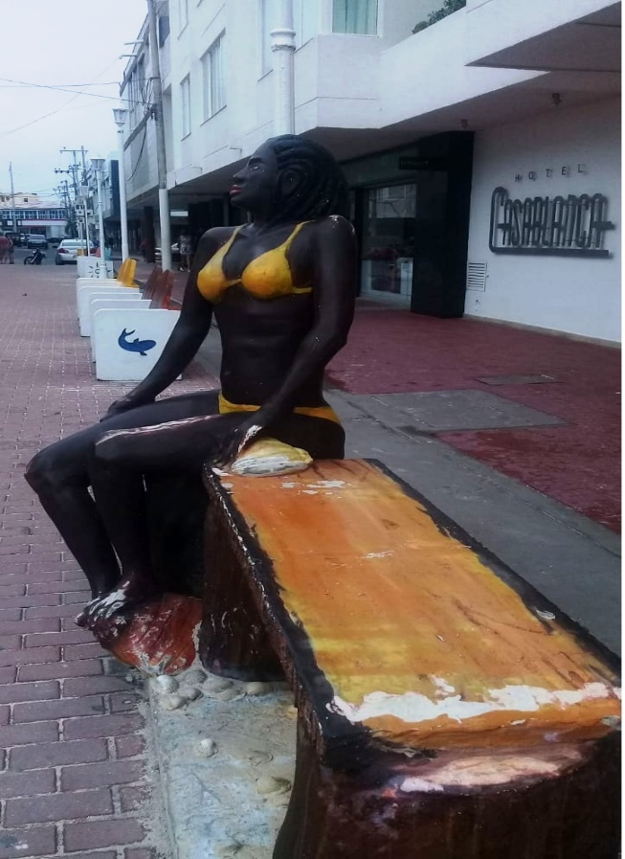 |  | 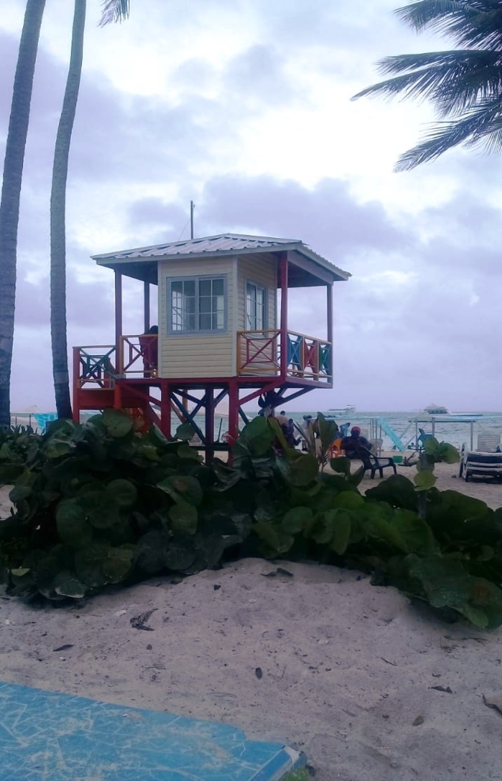
Hotel Casablanca Sculpture |  | Lifeguard Tower
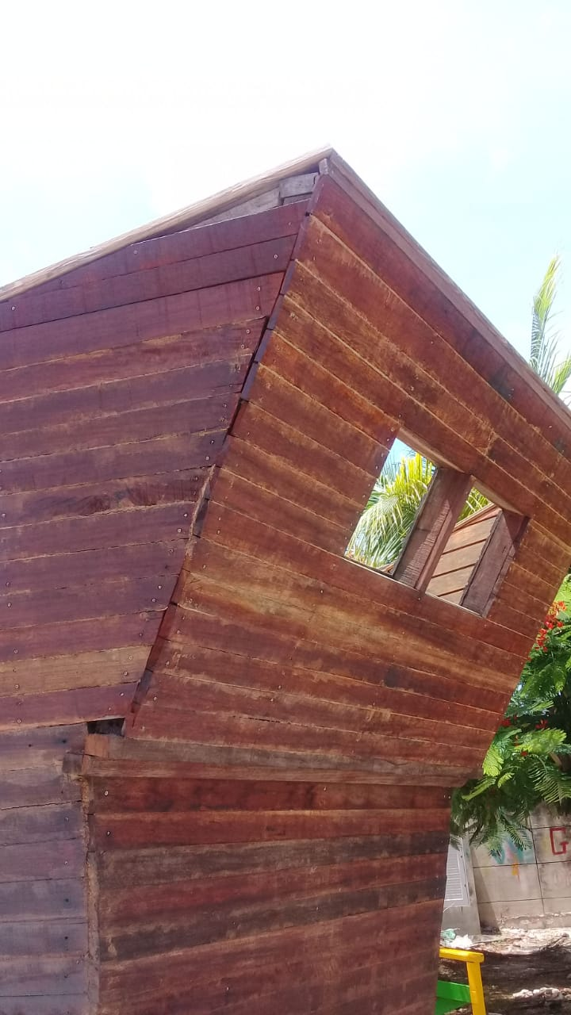
Airport Street Boat Sculpture
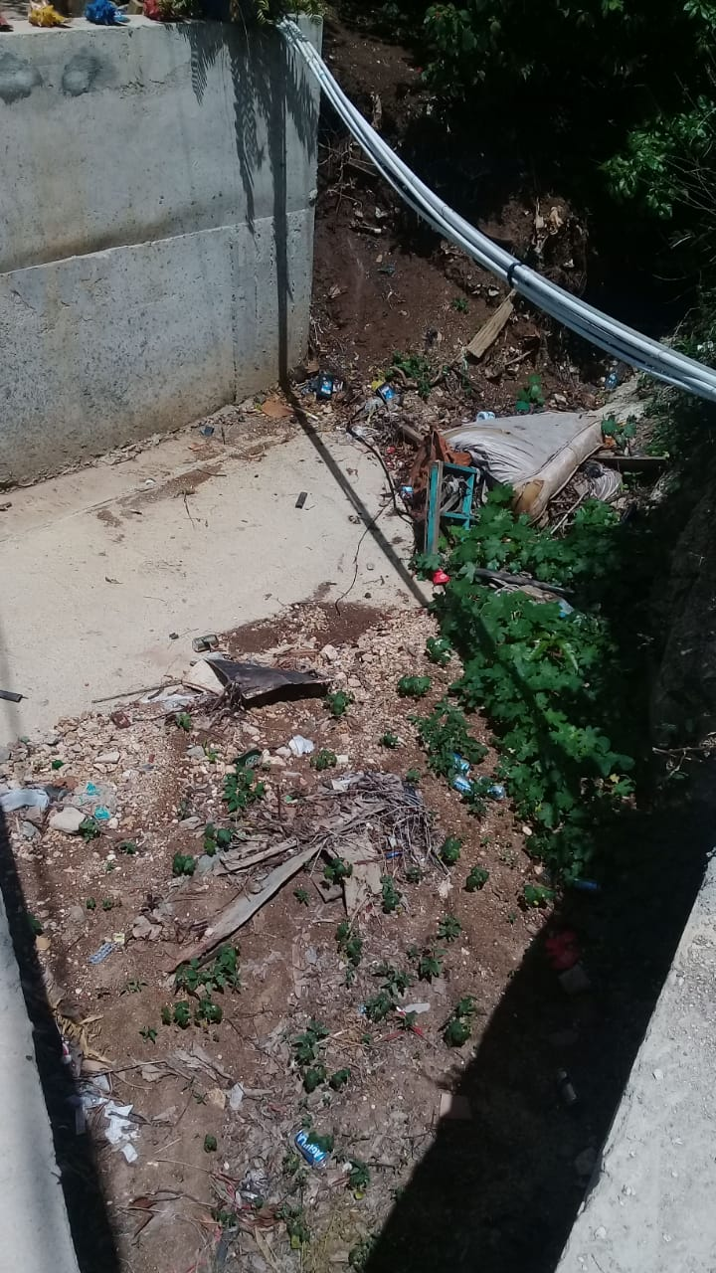 |  | 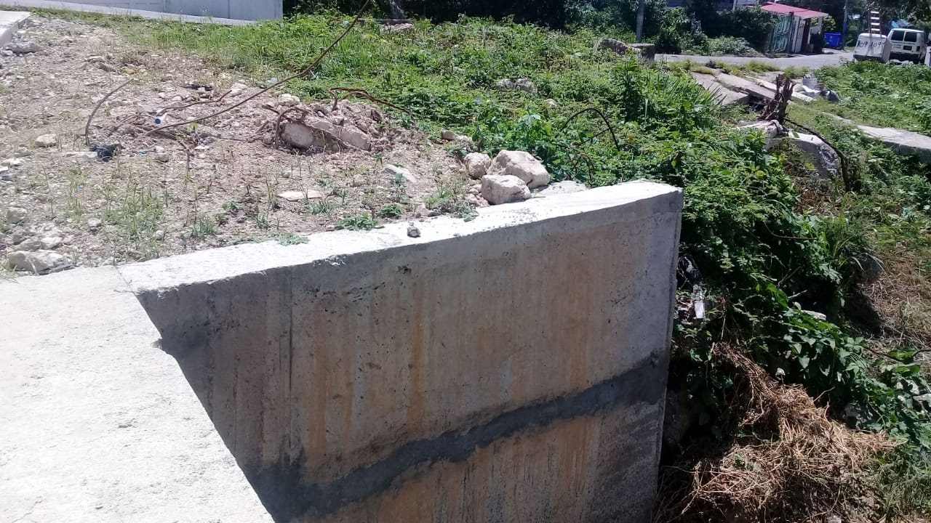
Adaptation and maintenance of paved roads “Orange Hill” sector
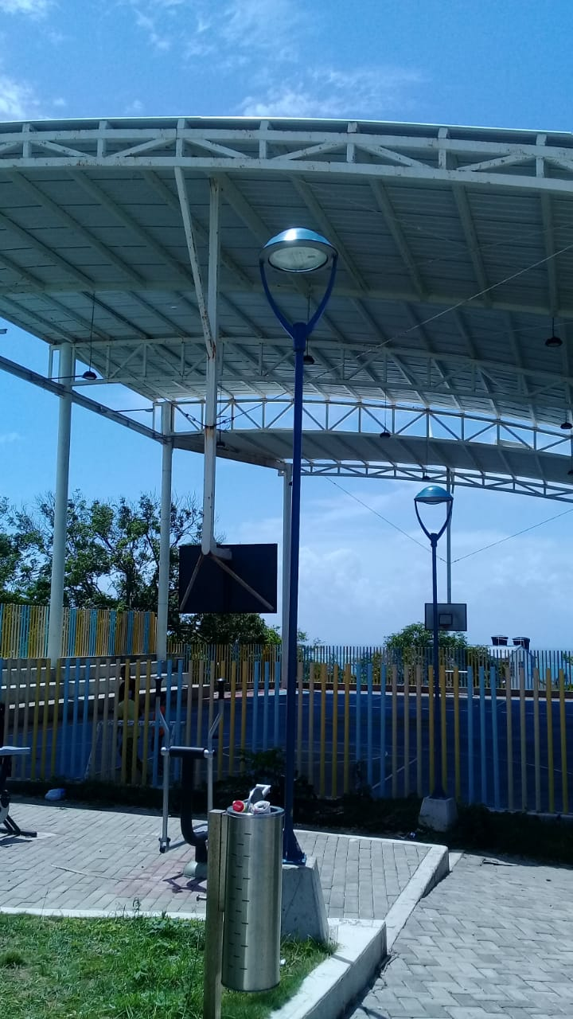 |  | 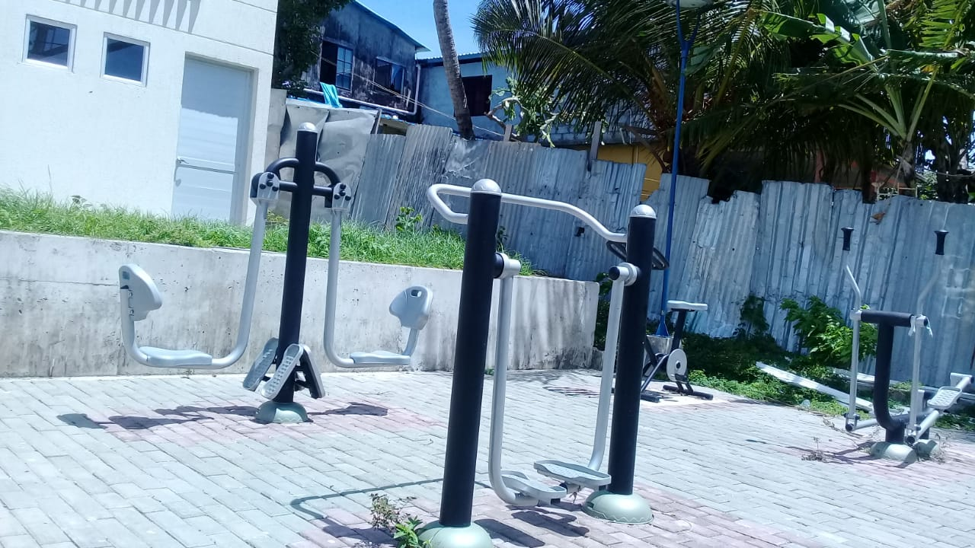
“Barrack” Sports Center
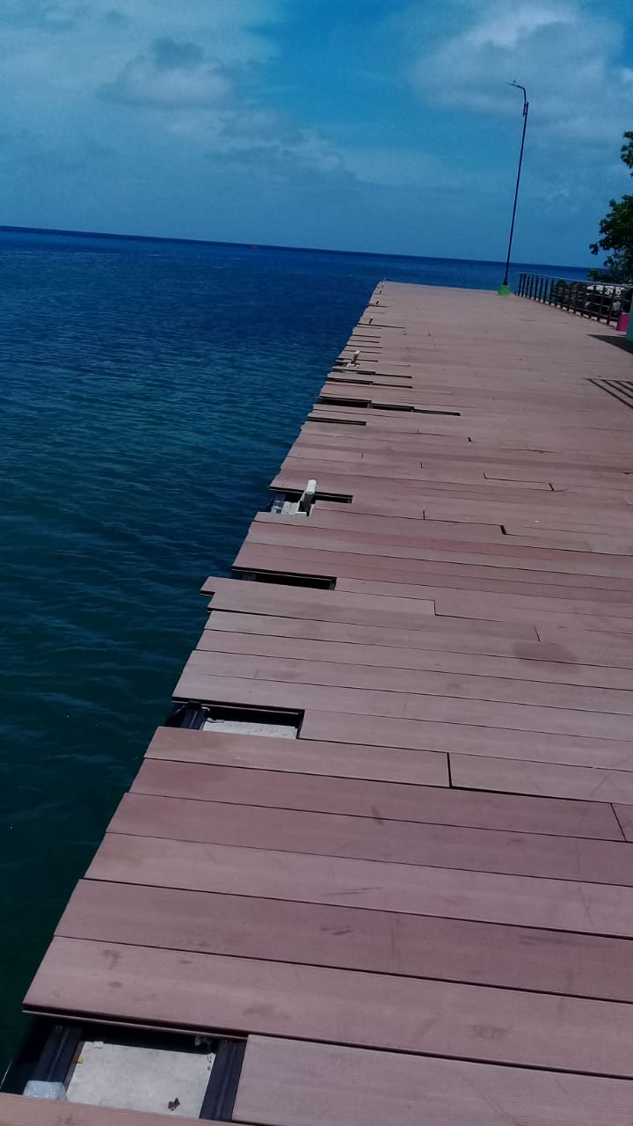
Cove Sea side Tourist Dock
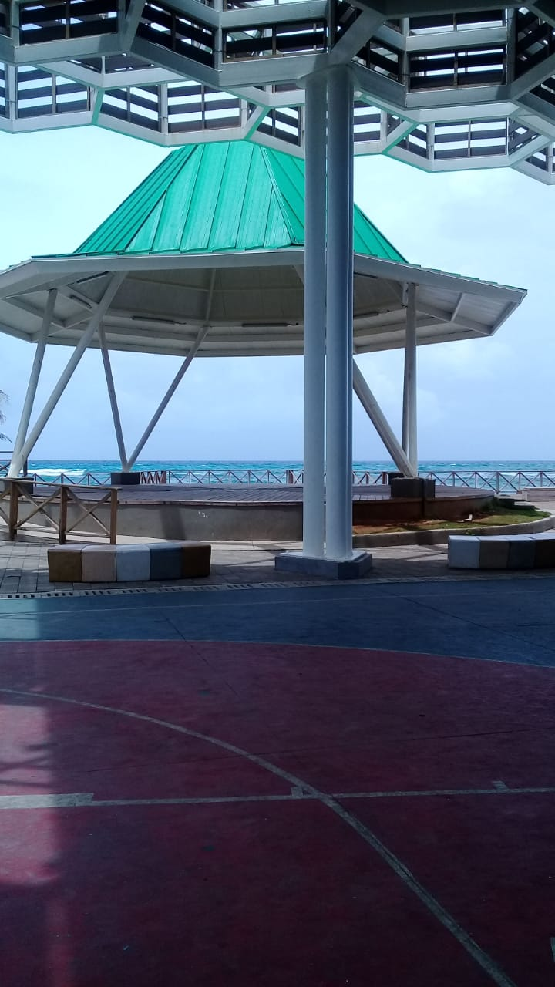
“El Rancho” Sports Center
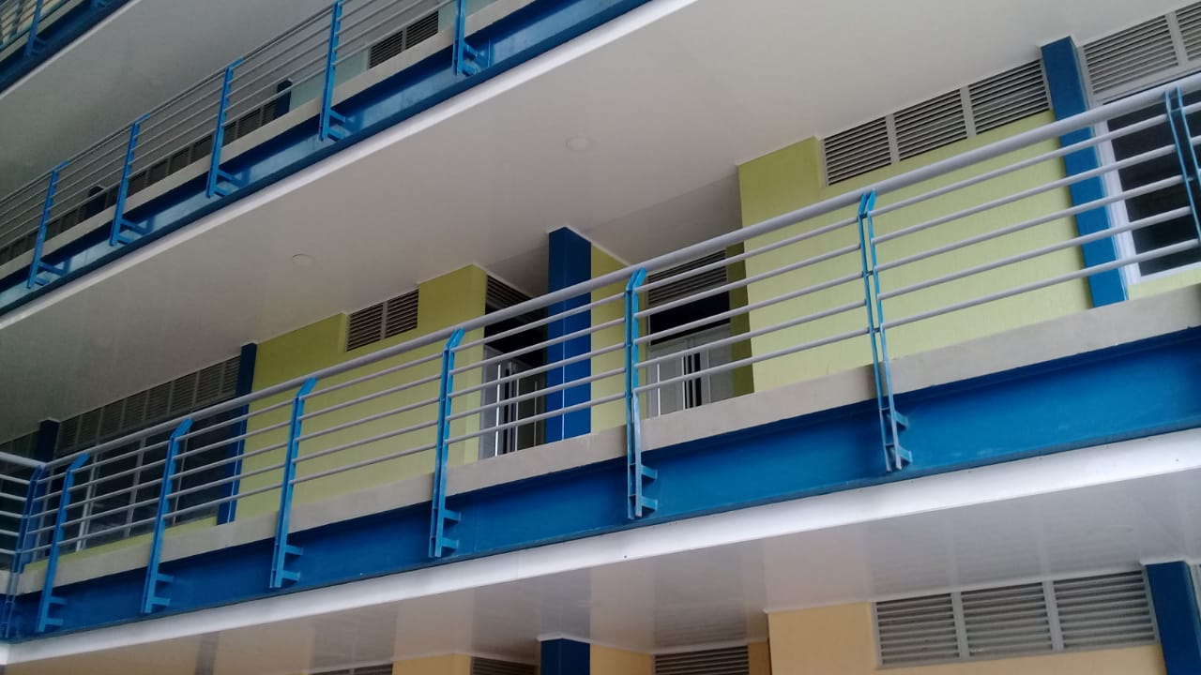 | 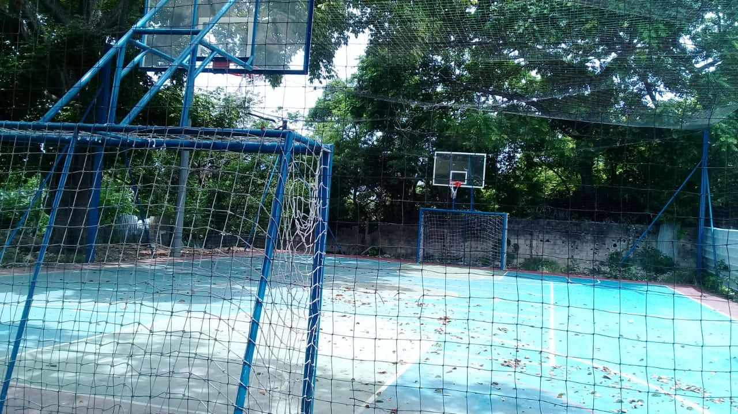
Bolivariano Institute

OBSERVATIONS AND RECOMMENDATIONS

- The information presented by the Secretariats must be adjusted with those of Planning since there are many discrepancies between the secretariats and planning.
- At the Accountability Report, the results of what has been done but also what has not been done and the reasons why they were not done must be given.
- At the Accountability Report, the results of the different audits carried out to the territorial entity, must present.
- The action of the Territorial Directors is a continuous action, therefore when there is reprogramming of the indicative plan and or modifications of the budget, said reprogramming and modifications must be formally presented to the directors.
- Faced with the presentation of the evaluation and progress of the Development Plan, it is extremely important not only to present the economic figures but also the impact generated by said program, sub-program and / or goals made by the Administration with the resources.
- Have a physical space in the Administration where the use of resources of the General Participation System can be analyzed since they are delicate documents that we do not consider appropriate to be copied or removed from the Administration.
- You have to work on the 93 goals that have not yet been worked on of the 498.
- The results of the evaluation of the goals should reflect the impacts and benefits received by the Raizal People, considering that we are in an ethnic territory and there are differential policies.
- The topic of the Sustainable Development Goals must be socialized with Administration Officials, since they are unknown.
- Resources must be allocated to the Sustainable Development goals.
- At the Secretariat of Social Development in the program of Comprehensive Care for Victims. The subprogram; Enjoy your rights appears twice, one must be deleted. Page three (3).
- We must review goal by goal in all the Secretariats since they present inconsistencies.
- The subprogram: More Raizal Cultural Identity for tourism promotion found in the Development Plan, page 336 does not appear in the compiled document by the Planning Department, therefore it must be included.
- Do not receive unfinished and / or defective works.
- The adaption and maintenance of unpaved roads and the maintenance of the storm drain system of the Department must be a constant work.
- The subprograms of: Intercultural Education Model and More Education for the population linked to the Criminal Responsibility System for Adolescents, which is in the Development Plan on page 105 and belong to the Affordable and Inclusive Education program; it is not found in the compiled document of the Planning Secretariat; therefore, it must be included.
- The subprogram: More Bilingual Education belonging to the “Educational Quality” Program found on page 107 of the Development Plan. The goals of: Approved Departmental Linguistic Policy and Implemented Departmental Linguistic Policy are not reflected in the compiled document.
- Emphasize on programs with low compliance scores.
- The fact that the Departmental Planning Council fully fulfills its functions should not be a reason for the Departmental Administration to forget that the Council needs a physical space with all the facilities, where we can carry out their functions with greater efficiency, and not having to depend on outsiders to lend us a space, or a computer or to give us a photocopy. We recommend taking this into account, so we do not continue as orphans, or begging on the street what by law correspond to the Departmental Administration to do.

In these terms, we leave register the Evaluation of the Departmental Development Plan “LOS que SOÑAMOS SOMOS MAS,” corresponding to the year 2018.

Yours truly,

ANTONIO ALEJANDRO SJOGREEN PABLO
President

